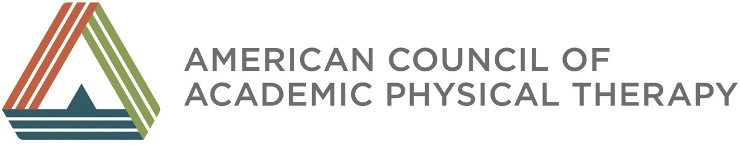

ORAL HISTORY SNAPSHOTS
Reflections of Key Leaders Across Time

Beth Domholdt, PT, PhD, FPTA

Dr. Domholdt, as a leader in many aspects of higher education, what are some of your reflections about the growth of academic physical therapy across your career?
From my viewpoint, the expansion of the type of institution that hosts physical therapy programs or sponsors physical therapy programs has been incredibly important to the growth of the profession. But that expansion is not without controversy. There are individuals who believe that smaller private institutions with physical therapy programs aren’t doing what they ought to do, particularly with respect to scholarship, compared to programs at public or private research institutions.

But that belief made physical therapy education a hotter commodity. When PT began to be offered at the graduate level, some of those smaller institutions were looking for the next thing that would help them grow and give them a head against the decline in traditional undergraduate populations. PT, as well as OT and PA, and other very high quality, non-medical professions really fit the bill for those institutions. Some of those institutions have been very creative and have really pushed everybody to “up their game” and think of physical therapy education a little bit differently.

Because you created a scholarly environment at two small schools what were the challenges and successes you encountered with research and scholarship?

At those institutions, we didn’t have startup packages for faculty, we didn’t have external funding, and we didn’t have light teaching loads. We did scholarship despite some of those institutional drawbacks - very efficiently and in areas for which people had passion. You approach scholarship differently when funding is an expectation when you have reduced teaching loads to do scholarship than when scholarship. Scholarship may have to be done in the corners of one’s work.

Is the type of knowledge different when it is generated through scholarship at institutions that don’t have a strong research imperative?

We did a different type of research. We were not doing randomized controlled trials, but that’s not the “be-all and end-all of research”. If you think of a Boyer framework, we did more synthesis, application or educational research, rather than the scholarship of discovery. But those other types are needed, particularly synthesis, when you have so much literature that nobody can absorb it and keep up with it. Synthesis is how you’re going to help translate knowledge into practice by providing some accessibility of that knowledge. I believe every physical therapy education program needs to be engaged in research and scholarship on some level. It is just going to look different based on your institutional mission and on your resources.
As a strong proponent of faculty remaining active in practice, how did you develop that in the programs and institutions you have been associated with?

We had a deeply pragmatic approach to this topic. Our mission, the reason we exist, is to be a practitioner. And, if we are going to do that we have to have faculty engaged in practice, we have to engage students in practice, and this has to be cutting-edge practice. Because I was at institutions without academic medical centers, we had to develop connections in different ways. At the College of St. Scholastica, there was a collaborative clinic with the local community college, in part to ensure that PTs and PTAs knew how to work together effectively. There was also a strong service orientation at the institution and the PT program was doing pro-bono care on the St. Scholastica campus – for many years, in hallways without dedicated space. Now, the PT, OT and PA programs have been re-located to a new facility and are serving the community by providing pro bono care, as well as exposing our students to interdisciplinary practice early in their career. We did similar things at the University of Indianapolis. I am now at Cleveland State University, a public research institution, again with no academic medical center, but a very strong urban commitment. Our PT students participate in free clinics and in an organization that provides healthcare to homeless individuals in Cleveland. This gives them an early opportunity to develop their therapeutic voice and their therapeutic presence and the ability to work with individuals in very different circumstances than they are personally. These kinds of things serve both an educational function and they help meet institutional missions.
From your current vantage point, do you have an opinion about the current reputation and activity of ACAPT as a new component of APTA?

When I was a new program director in the late 1980s and went to my first meeting of the program directors, I came away so dispirited because the environment was what I later described as a “vortex of negativity”. It seemed that when people I knew to be capable and doing good things in their programs got together, they felt they were victims of their institutions. There was this very negative vibe and this sense of not having any power or prestige or ability to gain resources. I believe that conversation has changed. The Section of Education and Program Directors had a series of leaders who took a more optimistic, solution-based approach. They stopped being victims of their circumstances and started looking for opportunities within in their organization to shine and grow and develop in new ways.

Could you make recommendations for the program directors in academic PT who are learning and continuing to grow, for what would you like to see them do?

I would like to see them understand that their program operates within a larger institutional context, and to gain resources and visibility in their organization, they must become politically savvy about where their institution is going, how to support the broader institutional context and how being less insular will lead their programs to grow, develop and thrive in this context.

Thank you, Beth, for your exceptional leadership and insight and for sharing your experience in academic physical therapy and higher education with the members of ACAPT.

