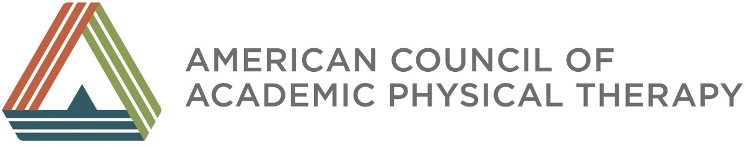
ORAL HISTORY SNAPSHOTS
Reflections of Key Leaders Across Time

Samuel Feitelberg, PT, MA

From your perspective as a member of the Council of Physical Therapy School Directors, what functions and impact did the Council have, and what caused its dissolution?

I knew of the Council because of my long-time friendship with Geneva Johnson whose goal always has been to strengthen physical therapy education. In 1965, I went to a meeting of the Council with two other men (one of whom was Wilbur Moen from Philadelphia). Standing in the back, we wondered how three men would be received among all the very special women (like Mary Callahan and Fran Tappan) who were school directors. The meetings were wonderful – high on planning and getting tools for running the programs. Grant funding from the government helped, but when the funding ended APTA began to want to take part in physical therapy education and a younger group began to participate in academic leadership. Even though women were concerned that men were taking over, we worked together and each of us was assigned an experienced director to help us with our programs. I was a leader in the Council and worked with Margaret Moore and others to consider integrating the Council into a new Section for Education that was being planned. The core concern was that we would lose power as a Section, where outside the association we had power and expression. That concern may have caused Margaret Moore to change the plan we made to integrate the Council into the APTA, and prompted school directors from Boston to refuse to support the Section. We continued to develop the section anyway and I became a Section officer when Fran Tappan was still President of the Council. In the early 1970s, the Council voted to dissolve, and Fran and I traveled to Philadelphia to make that happen legally. However, she felt we had lost our footing.

What was the biggest challenge facing the new Section for Education?

The biggest challenge was our desire to separate accreditation of PT education from The American Medical Association (AMA). Very soon after the Section for Education became a reality, I was asked to take a position on AMA’s Committee on Allied Health Education and Accreditation (CAHEA). To educators in physical therapy, CAHEA was a “dirty word”, a group made up of all the deans of schools of PT who did not want to see AMA lose control of physical therapy accreditation. However, it was very exciting to see how AMA’s Council on Medical Education, which oversaw CAHEA, eventually supported this decision! The Council members ended up censoring Keith Blayney from Alabama who was the chair of CAHEA and vehemently opposed to physical therapy having independent accreditation. Censorship was in response to a very anti-PT letter he wrote on CAHEA stationary that led AMA to replace Dr. Blayney as chair of CAHEA. The theme of my testimony to the Council on Medical Education for the independence of PT accreditation from AMA “Let My People Go”! For a few years CAHEA did continue to accredit physical therapy programs if specifically requested to do so; but, eventually, all PT programs left CAHEA and have been accredited by the Commission on Physical Therapy Education (CAPTE) since that time.

After all this change, how did the Section contribute to the growth of academic physical therapy?

Although not always afforded proper respect for their contributions, the Section had leaders such as Jane Matthews and Geneva Johnson who promoted new visions of the profession, its education and its practice. These leaders often had a more global picture of where we should be and how we should move forward - and many of us pursued those ideas. For example, I served on the licensing board. In my 1969 report to the New York Medical Board (which was all physicians) I proposed that physical therapy would eventually be a DPT. This resulted in my being impounded immediately, and moving to Vermont in 1970 to start a school without the influence of physiatrists. I was joined by Dot Page, Mary Moffroid (who eventually became president of CAPTE), Mike Emery, Judy Anderson and others to build a program that prepared graduates to practice without a referral. Not only was the school successful, but we were successful in influencing state law to minimize the referral requirement in Vermont. The physicians in the Governor’s office was very accepting, because physical therapy was delivered in communities and not in cities. We also had tremendous support from people on the Vermont Medical Board and from the senators who supported this legislation. Thus, ideas promoted by Section leaders did yield new vision!

What are your thoughts about the potential impact of ACAPT and its members on academic physical therapy?

First, I would like ACAPT to evaluate what has been achieved by the DPT? I have great concern that out in the community, in hospital settings and in the private practice sector we have not seen significant change in clinical practice since the DPT degree emerged. We are accountable to show better or different outcomes, not just that patients call us “doctor”. The title is not as important and the work we do. Second, I continue to think that accreditation should be separate from APTA. When not separate, political pressures within the association can complicate accreditation. There needs to be freedom in APTA and freedom in the schools and one should have no authority over the other. I have always felt that schools should be separate like the original Council of PT School Directors and I made this point the central theme of my master’s thesis. Third, we make a mistake by not working actively with AMA and the nursing and health professions groups that are important in our environment. IN my view, we have shied away from developing a strong, professional relationship with AMA. As my own physician has pointed out, physical therapists are rarely (if ever) members of hospital boards - unlike nurses who do serve in distinguished positions in the hospital environment. We need to be recognized for our clinical expertise and our leadership in health care – and, again, the title of DPT alone is not sufficient for this recognition. I believe that ACAPT can influence the reputation and professional standing of physical therapy in health care and academia – but it needs to be independent from APTA. I hope ACAPT seriously considers independence!

Sam, your insights and wisdom are so appreciated. Thank you on behalf of ACAPT and everyone for your leadership and contributions to our careers.

