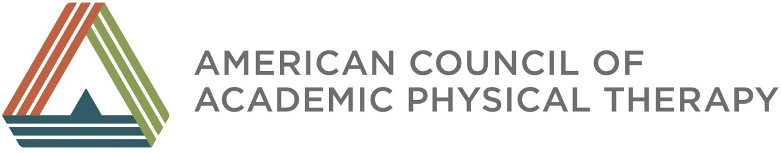

ORAL HISTORY SNAPSHOTS
Reflections of Key Leaders Across Time

Robert Bartlett, PT, MA, FAPTA

Bob, you have held numerous influential leadership positions in physical therapy, including APTA President, that give you a unique perspective on the history of our profession. Thinking back on the past 50 years, how would you describe the status of physical therapy and the changes that occurred in physical therapy education across those years?

In our early years, we didn’t have true professional identification; we were a vocation. Our early leaders in education did a tremendous job of seeing what was happening in the clinic and looking forward to see where the clinical side of the profession was moving. They made continual changes in their certificate or baccalaureate level curriculums – all without a great deal of science, but with great foresight and wisdom. Even with that foresight, we didn’t have a lot of recognition on campuses, except that physical therapy provided funds for the numerous academic programs that were starting in the allied health professions.

Then, in the 1950s or 1960s, we started taking responsibility for our academic programs, especially in accreditation. In fact, we took the bold step of separating ourselves from the American Medical Association’s Council on Medical Education and assumed independent accreditation for physical therapy programs. Even though AMA wanted to continue accrediting our programs, leaders in PT education refused to participate and our APTA accreditation program became a full-fledged reality. This reality met considerable “push back” from both the AMA and the American Hospital Association (AHA) - but not as much push-back as when we took the post-baccalaureate position. Those years were unbelievable!

What groups pushed back on the change to post-baccalaureate education for physical therapists and what people in our profession helped to make that change?

One of the stronger groups was the Deans of Colleges of Health Related Professions and their Presidents, who were joined by the AMA and the AHA. The opposition was political, but our decisions were based on the work of a six-person task force who spent several years studying what the terminal degree should be at the end of an academic program. Their work put us on solid ground as we moved forward to take that position. As Vice President of the APTA, I was proud to support that position, along with numerous others who were good thinkers and whose ability to look at things objectively made moving forward a lot easier. Some of these people were Jane Matthews, Marilyn Gossman, and Nancy Watts, but there were many who participated to make this happen. It was a great time!

What do you think now that we have moved all the way to the clinical doctorate as the ultimate degree designation and level of education for physical therapy?

I totally agree with the granting of the DPT. To me, the degree is commensurate with what the physical therapist does in the multiple clinical settings in which we practice, the degree of independence we now have and the changes we have seen in our health delivery system. To move in that direction, we didn’t just roll over our old curriculum and give it a new title. With good leadership and strong educators, we responded to what was happening in the clinical environment and the changes that were occurring sociologically. The DPT curricula are markedly changed from their predecessors.

You were a leader in the profession, when the Education Section developed the Academic Administrators Special Interest Group (AASIG), the precursor to ACAPT. What do you remember about the Council of PT School Directors and/or AASIG and their influence on PT education?

I was not deeply involved in the Academic Administrators group. In the 1950s and 1960s, Academic Administrators didn’t have power, and were not involved at the political level of the association. They did contribute to revising and implementing the essentials, on-site accreditation visits, and many things that helped us move forward with credibility. Also important during this time, however, was the evolution of the Foundation for Physical Therapy (FPT). Because we didn’t have many people with PhDs, the FPT started offering support for people to get these degrees as well as to conduct research to build our body of knowledge. The FPT contributed to developing many of our great thinkers. I don’t think academic physical therapy would have moved forward without helping these individuals. I was on the FPT Board when Charles Magistro was the FPT President. Then, I chaired the FPT Board for 10 (very challenging) years. At that time, a lot of the profession didn’t think we should be doing research, and they certainly didn’t want to contribute to the Foundation. Compare that to the success FPT is having today!

In view of all of your background, what is your view of the reputation of ACAPT, and its potential for making more bold moves for academic physical therapy?

In a broad sense, ACAPT is a group that can provide direction as physical therapy education evolves. It can be a force in the political environment of higher education. It seems that ACAPT is functioning in a very positive way and that it can gives voice to what is happening on the academic side of the profession. I would like to see ACAP be the moving force for developing faculty to understand how change takes place and to help people who don’t have a lot of background develop way(s) to function in the academic environment. Leadership training is very important. People serving in academia need to know what you have to do to move physical therapy forward in a positive direction.

Do you have one final recommendation for how we might promote excellence in physical therapy?

Be positive and strong. Look forward with a smile. Take your lumps and still move forward. That is what we did in the 60s and 70s. We took our lumps and we realized that we were getting attacked, and yet we believed in ourselves, and not in a way that was unreasonable. I think we had reasonable expectations and goals, and we were committed to move forward in positive ways to achieve those goals.

You have been a role model and mentor to all of us and that is wonderful advice! Thank you so much Bob Bartlett for all your wisdom and insight, and your many contributions to physical therapy.

